EXP NO: 05 Mobile Acquisition NAME : ADHIYAN PERIYAR R P

DATE: 07/08/2025 ROLL NO : 231901002

AIM:

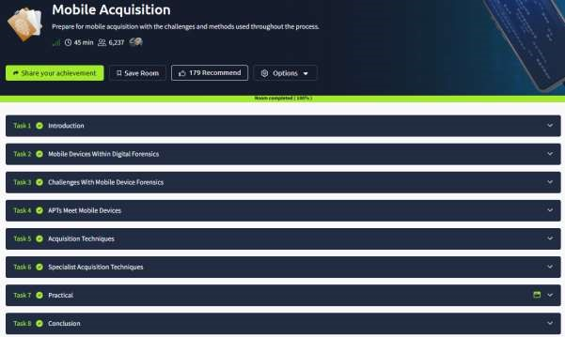

Task 1 : Introduction



Task 2 : Mobile Devices Within Digital Forensics

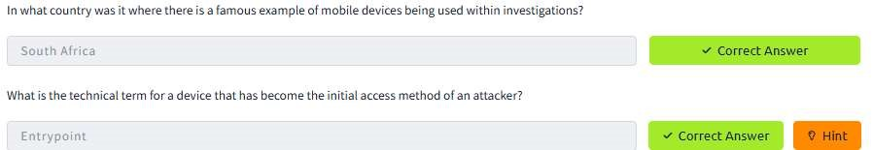

Task 3 : Challenges With Mobile Device Forensics

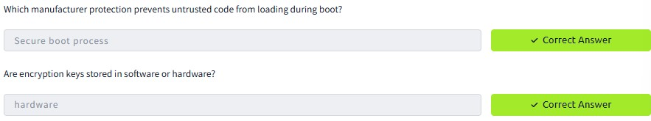

Task 4 : APTs Meet Mobile Devices

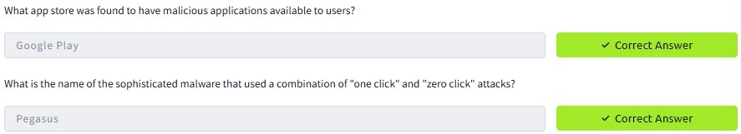

Task 5 : Acquisition Techniques

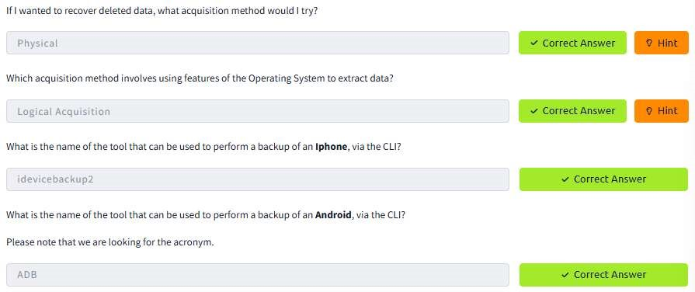

Task 6 : Specialist Acquisition Techniques

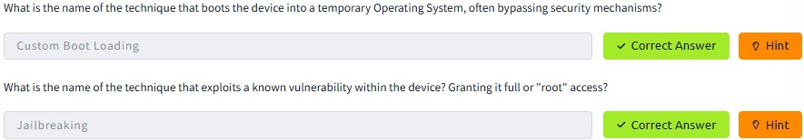

Task 7 : Practical

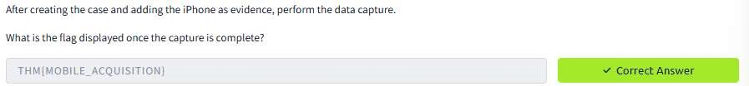

RESULT :

Mobile Acquisition is successfully completed in tryhackme platform .